The dataset I used for my questions and answers was located [https://www.kaggle.com/maxhorowitz/nflplaybyplay2009to2016 and was the 2009-2018](https://www.kaggle.com/maxhorowitz/nflplaybyplay2009to2016%20and%20was%20the%202009-2018) file. This file had the most data and columns to be able to dig into many different portions of the NFL teams and their plays.

1. What team is most susceptible to each type of play & direction?
2. The Detroit Lions were the most susceptible team over the middle by passing with an average of over 9.3 yards over 1278 passes over the middle. This kind of information can be used to show coaches where they need to focus film sessions and areas that offenses can exploit these defenses.

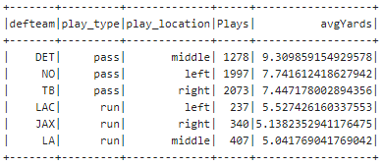

1. What team uses each type of play and direction the most?
2. Inversely of the last problem, here we can help the defenses prepare for which play type they are expected to see most. Expectedly, almost all the teams prefer to pass to the right as their main play option. However, there are three teams that prefer to pass left (NE, DEN, SD) and this kind of information is essential when facing their offenses to know where to line up your best cornerback and have the best chance to stop the offense.

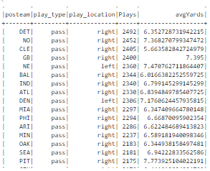

1. How much more likely is a first down to be picked up when between each group of 1-3, 4-6, 7-9, 10+ yards?
2. Constantly while watching the NFL or college football, the announcers constantly speak about how important it is to get a short third down to maximize opportunity to get the third down conversion and a new set of downs. Obviously, this makes sense, but how important is it really? When looking at the below chart, the difference between 1-3 yards and 4-6 yards is around 15%, which was the largest jump. The difference between 4-6 yards and 7-9 yards was the smallest jump with just over 9%.

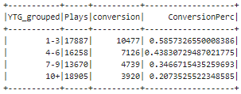

1. What team was the most likely to attempt a 4th down conversion instead of punting or kicking a field goal?
2. The team that was most likely to attempt a 4th down conversion was the Jacksonville Jaguars. I partially expected this result since they were not a great team during the stretch of this data and would often be behind and must make desperation plays to be able to try and come back. I expected this list to be very highly consisting of bad performing teams but was surprised to see teams such as NO, GB, ATL, PHI, etc. high up on the list as well which debunks my original theory. New Orleans was the most successful team at converting a 4th down attempt.

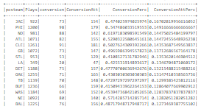

1. What teams combined for the most penalties and turnovers (only interceptions and fumbles, not turnovers on downs?
2. As with the last problem, I expected this to be a list of the teams with the worst record over the time. Oakland and Tampa Bay were number 1 and 2 on the rankings and only had one season each with a winning record. Seattle is where I became shocked. Seattle had a winning record every year of this dataset and you would not expect a team that penalized to make the playoffs that often. The summary is certainly skewed by penalties being so much more common than turnovers but penalties, fumbles lost and interceptions all very much contribute to losses and hurt chances to win

